Library Reservation system
Aim: To Develop a Library Reservation system by using Zoho CRM
https://creatorapp.zoho.in/https://github.com/raghu337/Cloud-computing-CSA1527

Procedure:
- Define three user roles: Student, Librarian, and Admin.
- Create separate pages for Students, Librarians, and Admin.
- Assign login and access permissions to each role using Zoho IAM.
- Allow Students to search for books and make reservation requests.
- Allow Librarians to approve, issue, and update book reservations.
- Allow Admin to view and manage all users, books, and reservations.
- Restrict access so each role can view only its own dashboard and pages

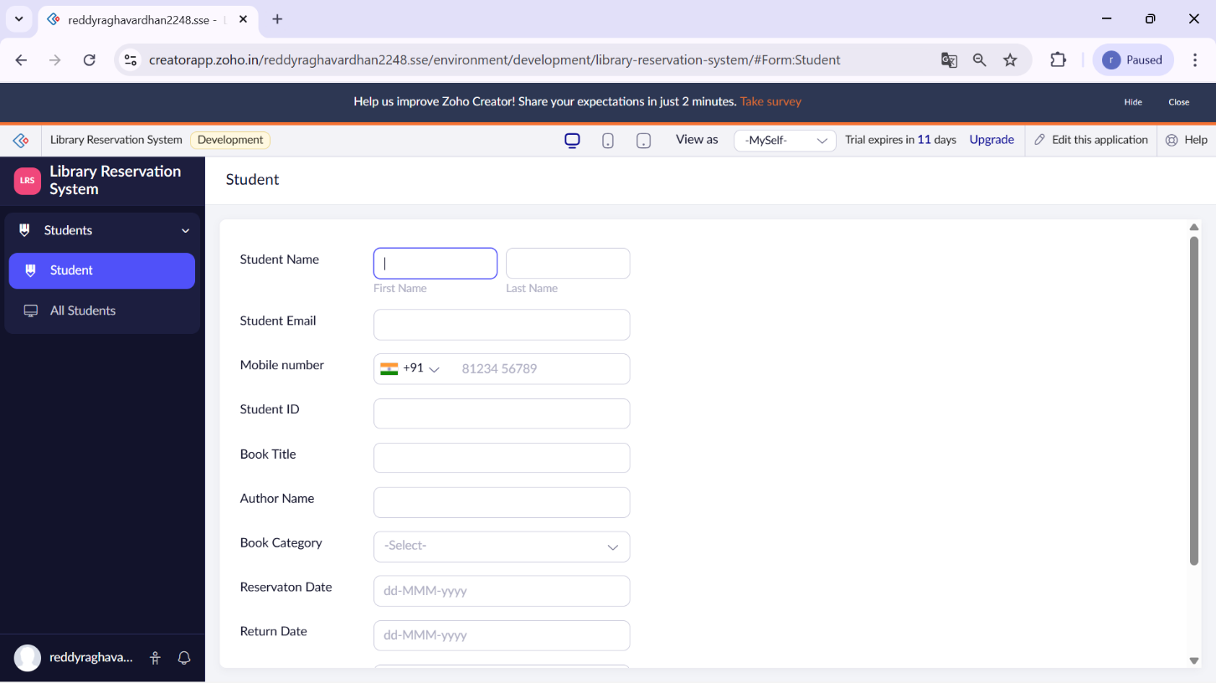

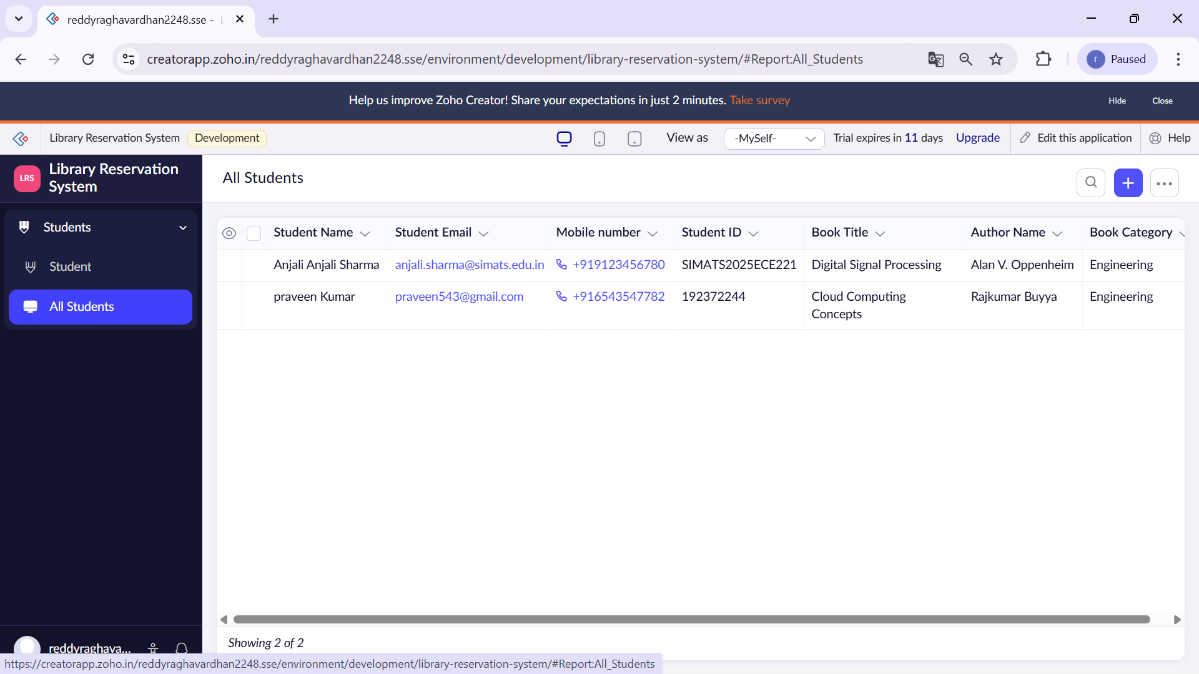

Result:
The Library Reservation System was successfully implemented as a cloud-based SaaS application using Zoho Creator and Zoho IAM. Students were able to search for books and submit reservation requests online, librarians could approve and manage book issues and returns, and the admin had full control over users, books, and reservation records. Role-based access control ensured that each user could access only their own dashboard and pages.

